Content for the COP microsite

Nav Item | Pages underneath
About | About Us · How It Works · Governance
Regions | Northwest Region · Centre Region
Evidence & Data | Evidence Hub · Data Hub · Knowledge Products
Get Involved | Join the CoP · Reports & Downloads · Contact

- Home page
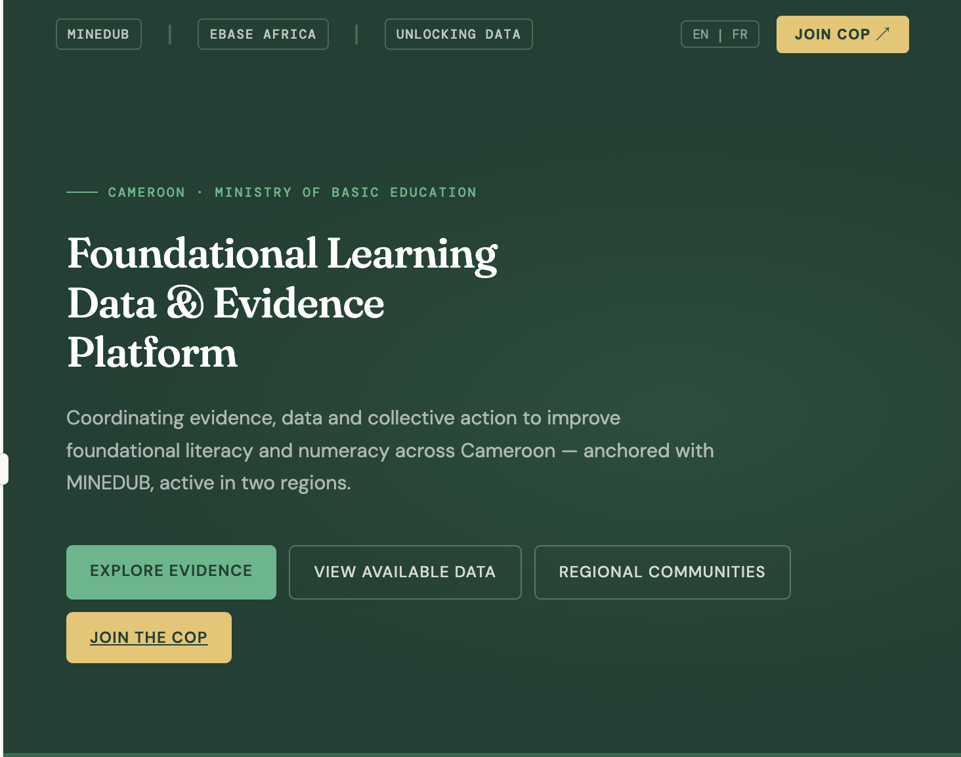

English | French
Foundational Learning
Data & Evidence
Platform

Coordinating evidence, data and collective action to improve foundational literacy and numeracy across Cameroon — anchored with MINEDUB, active in two regions.

CTAs Buttons:
Explore Evidence
View available data
Regional committees
Join the COP

About US
Why this platform exists
The parent initiative
The Unlocking Data Initiative (UDI) is a pan-African partnership, led by Zizi Afrique, ESSA, EdTech Hub and eBASE Africa, with support from GPE KIX and IDRC, designed to improve how education data is generated, shared and used for decision-making across Kenya, Malawi and Cameroon.
UDI in Cameroon
In Cameroon, UDI is implemented by eBASE Africa in partnership with MINEDUB. This platform, the Foundational Learning Data & Evidence Community of Practice, is a core UDI activity, bringing together government, researchers, civil society and development partners to strengthen evidence and data use for foundational literacy and numeracy.
What this platform aims to do
- Map education Data and close evidence gap
- Strengthen Evidence decision making in Minedub
- Build community of practice for collaborative data use
- Create a scalable model for cameroon and beyond
What we do
Four workstreams. One shared goal. The platform coordinates action across evidence, data, research, and systems so that every stakeholder, at every level, can make decisions grounded in the best available knowledge.
01

Evidence Mapping & Synthesis

View Evidence Hub

02

Research Agenda & Evidence Rush
View Research Agenda

03

Data Ecosystem & Transparency (explore the data hub)

04

Systems Innovation & DBIR Cycles (Learn more)

Regional communities
Two active regional clusters

Northwest Region
Conflict-sensitive system strengthening

Centre Region
Policy anchoring & ecosystem expansion
Our knowledge products
- EGM
- Situational Analysis

Evidence Hub
Where is the evidence and where are the gaps?

Data Hub
The FLN Data Ecosystem
A growing catalog of education datasets. Discover what exists in Cameroon, who holds it, and how to access it.

Ecosystem
Who is working on FLN and where?
Browse FLN initiatives and stakeholders active across Cameroon and register your own.
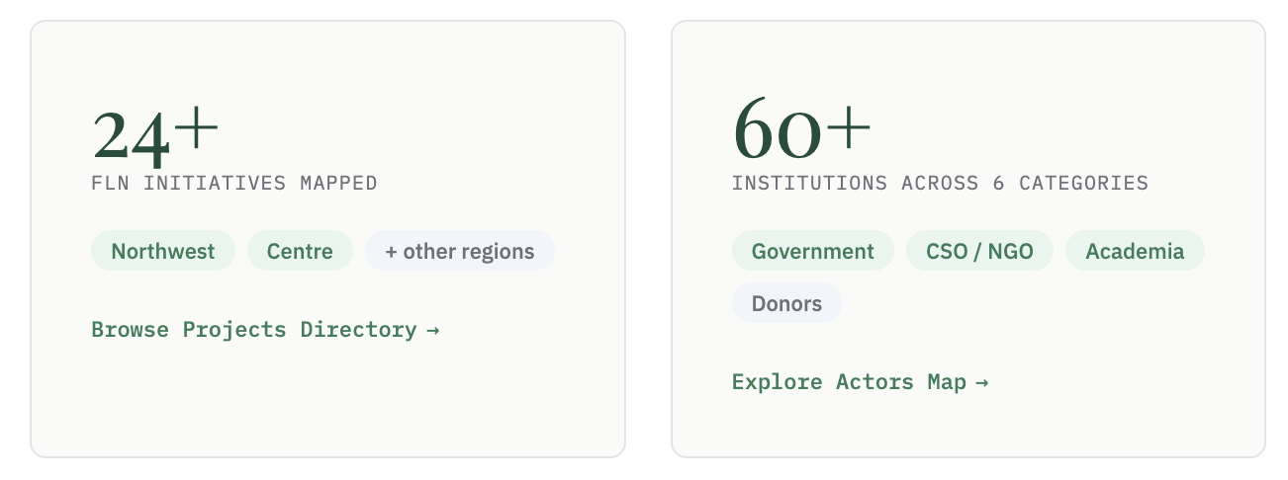

Get involved
Join or contribute to the CoP
The platform grows through collective contribution, from government partners, researchers, CSOs and development actors.
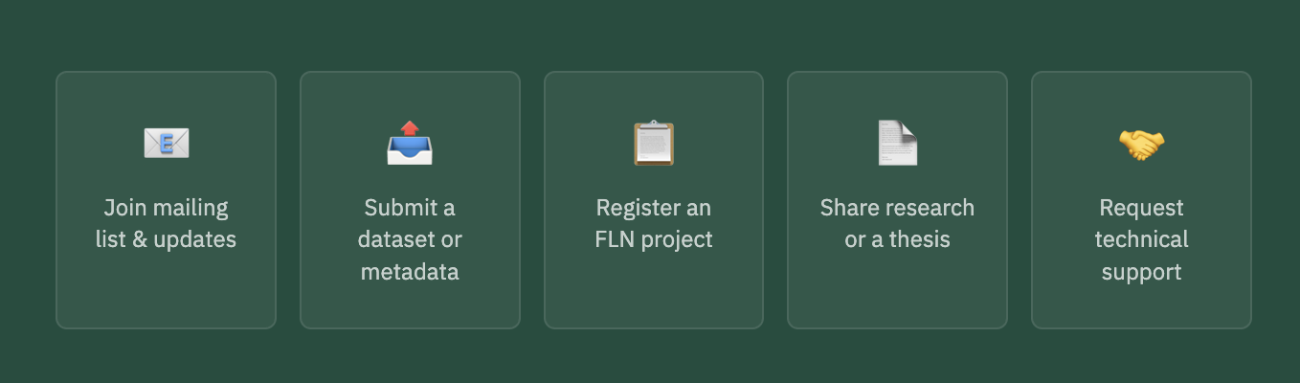

- Pages
About | About Us · How It Works · Governance

ABOUT US
Foundational Learning Data and Evidence Community of Practice
This platform is the public face of the Cameroon Foundational Learning Data and Evidence Community of Practice (CoP): a multi-stakeholder, ministry-led structure established to strengthen how education data is generated, shared and used. The work happens in the CoP. This platform makes it visible, accessible and actionable.

Section 1

Background
The Ministry of Basic Education (MINEDUB), recognising the critical importance of foundational literacy and numeracy (FLN) for the future of Cameroon's children, is committed to evidence-based decision-making to improve learning outcomes at all levels of the education system.
In partnership with eBASE Africa and as part of the Unlocking Data Initiative (UDI), MINEDUB has established Regional Communities of Practice to address systemic challenges in education data use and to foster an ecosystem where evidence, collaboration and innovation can thrive.
The establishment of these CoPs responds directly to the national situational analysis, the evidence gap map, and the identified need for stronger feedback loops, data use and collaboration among all stakeholders working on foundational learning for children aged 4 to 10 years.

Section 2

Purpose
The Community of Practice is a multi-stakeholder, ministry-led platform bringing together government officials, civil society, researchers, local government representatives, school leaders, teachers and development partners engaged in the generation, sharing or use of education data for foundational learning.
Its purpose is to facilitate peer learning, capacity building, joint problem-solving and the routine use of data and evidence in policy, planning and practice, with the ultimate aim of improving foundational learning outcomes for all children in the region.

Section 3

Objectives
The CoP pursues four objectives:
- To build knowledge on the most effective ways to scale the Unlocking Data approach in Cameroon, by piloting, documenting and adapting collaborative data use practices that can be replicated in other regions or nationally.
- To strengthen the capacity of policymakers, researchers, practitioners and other stakeholders to access, interpret and use data on foundational learning for better policy formulation, resource allocation, implementation and monitoring.
- To facilitate knowledge mobilisation and learning within and beyond the region through regular interactions, evidence sprints, thematic discussions, sharing of experiences and documentation of lessons learned.
- To advance equity and inclusion in data collection, analysis, sharing and use, ensuring that marginalised groups and underserved communities are represented, their voices are heard and their needs addressed in foundational learning actions and decisions.

Section 4

Core Functions
The CoP fulfils seven core functions:
- Serves as a forum for identifying and analysing key challenges related to foundational learning and data use at the regional level, drawing on diverse perspectives and sources.
- Reviews, interprets and discusses available data sources, including SIGE, INS household surveys, learning assessments such as PASEC, data generated by NGOs and CSOs, academic research and locally produced information.
- Develops and implements a regional learning agenda that reflects regional priorities, evidence gaps and emerging issues, while aligning with national policy objectives and the needs of children aged 4 to 10 years.
- Facilitates evidence sprints: focused, collaborative analysis or problem-solving sessions on urgent or strategic FLN issues, making use of pooled data and expertise.
- Systematically shares findings, lessons learned, practical examples and recommendations with MINEDUB at regional and national levels, to inform continuous improvement in education planning, implementation and system learning.
- Documents and disseminates stories of data-informed decision-making, success cases and tested innovations that can inspire replication and scaling across Cameroon.
- Contributes to the institutionalisation of best practices in foundational learning data use, supporting their adoption within existing government structures and policies.

Section 5

Membership
Membership is open to all stakeholders in the region with a commitment to improving foundational learning through the use of data and evidence. It is voluntary and free. The CoP strives to ensure balanced representation by gender, organisation type, region and inclusion of marginalised or underrepresented groups.
Members are expected to participate actively in meetings, evidence sprints and other activities, and to contribute to learning, documentation and the sharing of outputs.

Member category | Who this includes
Government officials | Regional and divisional officials of MINEDUB; representatives of the National Institute of Statistics (INS) and other relevant government agencies involved in education or data management.
Researchers and academia | Education research institutes, universities and individual researchers working on foundational learning or education data.
Civil society and NGOs | CSOs and NGOs engaged in foundational learning programming, research, monitoring or advocacy.
Councils and local authorities | Regional assemblies, divisional councils and other local authorities.
School heads and teachers | School leaders and classroom practitioners with direct experience of foundational learning delivery.

Section 5A

What membership offers
Participation in the CoP brings concrete, stakeholder-specific benefits. Here is what each member category gains.

Government Officials (Regional and Divisional MINEDUB, INS, Data Officers)
Direct access to NGO and CSO projects, data and insights from the field, expanding understanding beyond official statistics.
Exposure to a broader landscape of data sources such as CSO assessments and community-based research, providing richer context to complement EMIS and official reports.
Real-time intelligence about barriers and enablers of foundational learning as experienced in schools and communities.
Strengthened policy feedback loops: honest, field-based feedback on what is working and what needs improvement.
Trusted relationships with non-state actors for future data sharing, joint projects and collaborative planning.
Capacity building in data literacy, evidence interpretation and communication.
Possibility to jointly apply for funding with other CoP members and to direct existing resources toward priority FLN issues identified collaboratively.
Civil Society Organisations, NGOs and Community Groups
A direct channel to government to present data, evidence and insights to decision-makers, increasing the likelihood that their work influences policy and practice.
Opportunities to discover partners and build joint initiatives based on shared priorities, opening doors for collaborative projects, advocacy and joint resource mobilisation.
Guidance on aligning data collection, reporting and dissemination practices with government standards, increasing the acceptance and use of their evidence by policymakers.
Field-based peer learning: sharing challenges and effective strategies with others facing similar issues.
Recognition for outstanding contributions, innovation or learning through visibility in CoP reports, ministry updates or learning events.
Opportunity to co-design joint funding proposals or coordinate existing resources to address regional priorities.
Researchers and Academia
Alignment of research topics with government and field-level priorities, ensuring relevance and increasing the impact of their work.
Access to diverse data sources and field sites, facilitated by relationships with NGOs, schools and local officials.
A pathway to share findings directly with policymakers and practitioners, accelerating the translation of research into action.
Opportunities for collaborative, multi-stakeholder research potentially leading to larger studies or innovations.
Support for translating and communicating findings for non-academic audiences, increasing uptake.
Opportunities to partner in grant applications with government or NGO members, channelling resources toward regionally relevant research questions.
Councils, Regional Assemblies and Local Authorities
Ready access to the latest data and research findings relevant for planning, budgeting and oversight functions.
Evidence and field insights to advocate for local needs more effectively with regional or national authorities.
A platform for evidence-informed decision-making, supporting benchmarking and targeting of interventions where most needed.
Opportunities to identify and partner with NGOs, schools and researchers for locally led initiatives, pilot programmes or funding applications.
Strengthened capacity for monitoring and evaluating local programmes and policies.
Ability to collaborate within the CoP to channel local and external funding toward regionally prioritised FLN actions.
School Heads and Teachers
Classroom realities, student learning needs and innovative practices heard directly by data producers and decision-makers.
Accessible summaries and analyses of learning trends and best practices, supporting efforts to improve instruction and student outcomes.
Professional development through evidence-sharing sessions, data use training and the possibility of recognition as data champions.
Peer exchange: learning from other schools' successes and challenges.
Participation in pilots or interventions funded through joint proposals or resource reallocation.
All Members
Participation in a strong, trusted and diverse network where collaboration and mutual support help solve real-world problems.
The chance to contribute meaningfully to systemic change, making education data more open, useful and actionable for the benefit of all children.
Opportunity to participate in developing or joining joint funding proposals, or in coordinating existing resources, to maximise collective impact on regional foundational learning priorities.

Section 6

Structure and Roles
Role | Responsibilities
Chair | The Regional Delegate of MINEDUB, or their designated representative, chairs the CoP and provides formal leadership and policy oversight.
Technical Secretariat | eBASE Africa is responsible for coordination, documentation, communication and technical support to ensure the smooth functioning of the CoP.
Working groups | The CoP may establish working groups as needed to address specific themes or tasks, such as data analysis, monitoring and evaluation, capacity building, communications or special projects.
All members | Expected to participate actively in meetings, evidence sprints and other activities, and to contribute to learning, documentation and the sharing of outputs.

Our Values

What guides us

Respect for all voices and perspectives, regardless of role or background |  | Inclusion and non-discrimination, ensuring equitable participation and access for all
Commitment to continuous learning, innovation and the use of evidence in decision-making |  | Dedication to improving foundational learning outcomes for every child in the region
Transparency and accountability in all CoP activities and communications

Timeline

Key milestones
Year | Milestone
2024 | Unlocking Data Initiative launches across Kenya, Malawi and Cameroon.
2025 | Situational Analysis published documenting FLN data fragmentation in Cameroon. Northwest Regional CoP launched in partnership with MINEDUB-NW.
2025 | Evidence Gap Map released for Cameroon. Centre Regional CoP launched. Learning agendas developed for both regions. Evidence Rush activities conducted.
2026 | Platform launched publicly. Ongoing data mapping, CoP meetings, capacity building and evidence sprint activities across both regions.

Get involved

Join the CoP
Membership is open and free. If you work on foundational learning in Cameroon, whether as a government official, researcher, civil society actor, local authority, school head or teacher, there is a place for you here.
To join or learn more, contact the eBASE Africa secretariat (we have to add an email) — or visit the Join page on this platform.

Regions | Northwest Region · Centre Region

- North West
REGIONAL COP
Northwest Region
The Northwest Regional CoP on Foundational Learning Data was established in November 2025 in Bamenda. It operates in one of Cameroon's most complex education contexts — a region where socio-political conflict has disrupted schooling and fragmented data systems, yet where significant evidence on foundational learning continues to be generated every day by schools, civil society organisations, researchers and local councils. The CoP exists to bring that evidence together and put it to use.

AT A GLANCE

8  Priority research questions | [X]  Active members | 3  Convening organisations

GOVERNING INSTRUMENT

The Bamenda Charter
The Bamenda Charter is a binding regional framework ratified at the inaugural November 2025 workshop. It establishes the governance, ethics and technical protocols for collaborative data use in the Northwest Region, including protocols for safe data sharing and a mandate for offline-first digital architecture in response to the region's connectivity and security realities.
[ TO FILL ] Insert download link to the Bamenda Charter PDF

GOVERNANCE

Governing Board

Role | Name | Organisation
Chair |  | Regional Delegation of MINEDUB, Northwest
Technical Secretariat |  | eBASE Africa
Board Member |  | UCCC/NW
Board Member |  | [Organisation to be confirmed]
Board Member |  | [Organisation to be confirmed]

LEARNING AGENDA

2025 to 2026 Research Questions
The following eight research questions were formulated and adopted by consensus at the inaugural workshop. They will guide data collection, evidence sprints and synthesis activities throughout the 2025 to 2026 CoP cycle.

1 | How can we strengthen teacher retention, especially in rural areas?
2 | How can we motivate data actors to share data in a trustworthy, timely and safe manner?
3 | How can we effectively collect and use data on teachers' Knowledge, Attitude, and Practice (KAP)?
4 | How can educational institutions adapt to better accommodate learners with disabilities?
5 | Why are FLN outcomes declining despite the increasing number of trained teachers?
6 | How can we strengthen parental and caregiver involvement in children's learning?
7 | Which factors most influence learning outcomes in the Northwest Region?
8 | What support do FLN stakeholders need to produce, report, share and use data effectively?

Two alternate questions were also adopted and may be activated during the cycle as priorities evolve.

Link to the full Northwest Learning Agenda document Research Agenda - NW Region-2

GET INVOLVED

Join the Northwest CoP
Membership is open and free to any individual or organisation working on foundational learning data and evidence in the Northwest Region.
To join the Northwest CoP, contact the eBASE Africa secretariat: | Or visit the Join page on this platform.

- Centre
REGIONAL COP
Centre Region
The Centre Regional CoP on Foundational Learning Data was inaugurated in Yaoundé under the leadership of MINEDUB and in partnership with eBASE Africa under the Unlocking Data Initiative. Rather than launching new data collection or isolated projects, the CoP was established as a permanent multi-stakeholder platform for sustained system learning, structured around shared priorities, collective sense-making and the routine use of evidence to improve foundational learning outcomes for children aged 4 to 10 years.

AT A GLANCE

6  Priority learning domains | [X]  Active members | 2  Convening organisations

GOVERNANCE

Governing Board
MINEDUB serves as the institutional chair of the Centre Regional CoP, with eBASE Africa as Technical Secretariat. Task-based working groups aligned to the priority learning domains may be established as the CoP matures.

Role | Name | Organisation
Chair |  | Regional Delegation of MINEDUB, Centre
Technical Secretariat |  | eBASE Africa
Board Member |  | [Organisation to be confirmed]
Board Member |  | [Organisation to be confirmed]
Board Member |  | [Organisation to be confirmed]

LEARNING AGENDA

Priority learning domains and questions
The Learning Agenda was articulated and validated in plenary at the inaugural Yaoundé meeting. It is organised across six domains reflecting the Centre Region's most pressing evidence gaps. It will anchor CoP learning cycles and guide evidence synthesis and review throughout the current cycle.

Domain 1: Governance and system coherence
1.1 | How do coordination and accountability arrangements across central, decentralised and school levels affect foundational learning outcomes?
1.2 | Where do feedback mechanisms between schools, councils and the Ministry fail to inform corrective action?
1.3 | Is there a case for a dedicated national policy or strategic framework focused specifically on foundational learning, and how might this improve coherence and accountability?
Domain 2: Pedagogy and teacher practice
2.1 | Which classroom practices are most consistently associated with improved foundational literacy and numeracy outcomes?
2.2 | To what extent do current teacher training and supervision approaches influence classroom instruction and learner progress?
Domain 3: Inclusion, equity and social and emotional learning
3.1 | Which inclusive education approaches are effective for learners with disabilities and other vulnerable groups?
3.2 | Why do inclusive education policies encounter persistent implementation challenges at the school level?
3.3 | How do social and emotional learning competencies influence foundational learning outcomes, and how are these competencies currently supported within classrooms?
Domain 4: Parents, communities and learner behaviour
4.1 | How does parental and community engagement shape early grade learning outcomes?
4.2 | What role do learner motivation and attitudes toward schooling play in learning trajectories?
4.3 | How does the age of school entry affect foundational learning progression?
Domain 5: Financing, decentralisation and resources
5.1 | How do education investments translate into learning-supportive conditions at the school level?
5.2 | How do financing arrangements between the State and local councils affect the quality and equity of foundational learning provision?
5.3 | What accountability mechanisms exist to ensure that decentralised education spending supports learning outcomes rather than administrative compliance alone?
Domain 6: Technology and education data systems
6.1 | How can existing education information systems better support learning-focused decision-making?
6.2 | Which digital tools are relevant, credible and appropriate for improving data timeliness, analysis and feedback at different system levels?

link to the full Centre Region Learning Agenda document : CoP Workshop Yaounde-2

GET INVOLVED

Join the Centre CoP
Membership is open and free to any individual or organisation working on foundational learning data and evidence in the Centre Region.
To join the Centre cluster, contact the eBASE Africa secretariat: | Or visit the Join page on this platform.

Evidence & Data | Evidence Hub · Data Hub · Knowledge Products

EVIDENCE AND DATA
Evidence Hub
The Evidence Hub brings together the evidence produced, reviewed and mapped through the CoP's work across both regions. It is designed to show what is known about foundational learning in Cameroon, where the evidence is strong, where it is partial, and where the critical gaps lie.

EVIDENCE GAP MAP

What the evidence tells us
The Cameroon FLN Evidence Gap Map (EGM) is the CoP's primary evidence mapping tool. It provides a structured visual overview of existing research and evidence on foundational literacy and numeracy across Cameroon, organised by intervention type and outcome.
The EGM makes it possible to see at a glance where evidence is concentrated, where it is thin, and where targeted research is most urgently needed. It draws on systematic searches of published and grey literature, including government reports, NGO evaluations, academic studies and assessment data.

Embed interactive Evidence Gap Map here (EPPI-Reviewer / EGM tool embed code)

Download the full Evidence Gap Map: [Insert PDF download link]

EVIDENCE RUSH

What we found in the regions
Evidence Rush exercises were conducted in both the Northwest and Centre regions as part of the inaugural CoP workshops. Stakeholders assessed existing evidence against each region's Learning Agenda using a traffic light approach: green for strong evidence, amber for partial evidence, and red for weak or absent evidence.
The table below summarises findings by thematic domain across both regions. Full findings are available in the regional Learning Agenda documents.

Thematic domain | Northwest | Centre
Governance and system coherence | Partial | Partial
Pedagogy and teacher practice | Partial | Weak
Inclusion, equity and social and emotional learning | Weak | Weak
Parents, communities and learner behaviour | Partial | Partial
Financing, decentralisation and resources | Weak | Weak
Technology and education data systems | Partial | Weak

Note: Traffic light ratings are based on stakeholder assessments during the Evidence Rush exercises and should be read as indicative rather than exhaustive. They reflect what is known and available to CoP members, not a comprehensive global literature review.

SYSTEMATIC REVIEWS AND SYNTHESES

Synthesised evidence
The CoP draws on systematic reviews and evidence syntheses to anchor its Learning Agenda questions in the best available global and regional evidence. These are reviewed and discussed during CoP evidence sprints and used to contextualise local findings.

EVIDENCE AND DATA
Data Hub
The Data Hub is a growing catalog of education datasets relevant to foundational learning in Cameroon. It maps what data exists, who holds it, and how to access it — so that CoP members, researchers and decision-makers can find and use the data they need without starting from scratch.
DATASET CATALOG

Catalogued datasets
The table below lists datasets that have been identified, verified and catalogued with metadata. Access levels indicate whether data is openly available, available on request, or restricted.

Dataset | Producer | Coverage | Access
SIGE (Systeme d'Information et de Gestion de l'Education) | MINEDUB | National | By request
PASEC 2019 Assessment | CONFEMEN | National | Open
INS Household Survey (ECAM) | National Institute of Statistics | National | By request
EGRA/EGMA Assessment Data | Various NGOs and partners | Regional | By request
[Additional datasets to be added as mapping progresses] |  |  | [ ]

Open — freely downloadable | By request — contact data holder | Restricted — formal agreement required

ACCESS PATHWAYS

How to request data
For datasets listed as available by request or restricted, the CoP secretariat can facilitate introductions to data holders and advise on the appropriate process for data sharing agreements. Contact the secretariat to begin the process.
To request access to a listed dataset or to submit a new dataset for cataloguing, contact:

EVIDENCE AND DATA
Knowledge Products
All documents produced through the CoP's work are available for free download below.

GOVERNING INSTRUMENTS

Governing instruments

The Bamenda Charter  Governance, ethics and technical protocols for collaborative FLN data use in the Northwest Region. Ratified November 2025. | [Download PDF]

LEARNING AGENDAS

Learning agendas

Northwest Regional Learning Agenda 2025 to 2026  Eight priority research questions and Evidence Rush findings for the Northwest Region. | [Download PDF]
Centre Region Learning Agenda 2025 to 2026  Six priority learning domains and research questions validated by CoP stakeholders in Yaounde. | [Download PDF]

WORKSHOP REPORTS

Workshop reports

Northwest CoP Inaugural Workshop Report  Bamenda, November 2025. Outcomes, deliberations and next steps from the first Northwest CoP workshop. | [Download PDF]
Centre CoP Inaugural Workshop Report  Yaounde, 2025. Outcomes, deliberations and next steps from the first Centre CoP workshop. | [Download PDF]

POLICY BRIEFS

Policy briefs

policy brief titles and download links

SUBMIT A PRODUCT

Share your work with the CoP
CoP members are encouraged to submit reports, studies, briefs or tools for consideration. Submissions are reviewed by the Technical Secretariat before publication.
To submit a knowledge product:

Get Involved | Join the CoP · Reports & Downloads · Contact

GET INVOLVED
Join the CoP
Membership is open and free. If you work on foundational learning data or evidence in Cameroon, as a government official, researcher, civil society actor, council representative, school head or teacher, there is a place for you in this community.

WHY JOIN

What membership gives you
- Access to the latest FLN data and evidence from across both regions.
- A direct voice in shaping the regional learning agenda and evidence priorities.
- Peer learning and capacity building through regular CoP meetings and evidence sprints.
- Opportunities to co-produce knowledge, jointly apply for funding and coordinate action.
- Visibility for your organisation's work within the CoP network and beyond.

Full details of member benefits by stakeholder group are available on the About Us page.

REGIONAL CLUSTERS

Choose your cluster
The CoP operates through two regional clusters. Select the one that matches your geography and work. Members may join both clusters if their work spans regions.

Northwest Region  Convened by eBASE Africa, MINEDUB-NW and UCCC/NW  For stakeholders working in the Northwest Region. Focus areas include teacher retention, data sharing in conflict-affected contexts, learner disability inclusion and parental engagement. |  | Centre Region  Convened by MINEDUB and eBASE Africa  For stakeholders working in the Centre Region, including Yaounde. Focus areas include governance and system coherence, pedagogy and teacher practice, financing and decentralisation.

REGISTRATION FORM

Register as a member
Complete the form below to join. Fields marked with * are required. Your information will be used only to add you to the relevant cluster mailing list and onboard you into CoP activities.

Member Registration Form
Full name * | Enter your full name
Email address * | Enter a working email address
Organisation * | Name of your organisation or institution
Member category * | □ Government official (MINEDUB or related agency)  □ Civil society organisation or NGO  □ Researcher or academic  □ Council or local authority  □ School head or teacher  □ Development partner or donor  □ Other
Regional cluster * | □ Northwest Region  □ Centre Region  □ Both regions
Role / title (optional) | Your current role or job title
How did you hear about the CoP? (optional) | e.g. colleague, workshop, social media

After submitting, you will receive a confirmation email from the eBASE Africa secretariat within 5 working days. You will then be added to your cluster mailing list and sent onboarding information.

GET INVOLVED
Contact
For questions about the CoP, membership, knowledge products, data access or partnership, reach the eBASE Africa Technical Secretariat directly or use the form below.

SECRETARIAT

Technical Secretariat

Organisation | eBASE Africa (Effective Basic Services Africa)
Email
Response time | Within 5 working days
Location | Yaounde, Cameroon

CONTACT FORM

Send us a message
Use this form for general enquiries, partnership proposals, data access requests or media enquiries. Fields marked with * are required.

Contact Form
Full name * | Enter your full name
Email address * | Enter a working email address
Organisation (optional) | Your organisation or institution
Subject * | □ General enquiry  □ Membership and joining the CoP  □ Data access request  □ Knowledge product or publication  □ Partnership or collaboration  □ Media or press enquiry  □ Other
Message * | Write your message here

Your message goes directly to the eBASE Africa Technical Secretariat. We do not share your contact details with third parties.

